**Q2. Capture and analyze Ethernet frames using Wireshark. Inspect the structure of the frame, including destination and source MAC addresses, Ethertype, payload, and FCS Use GNS3 or Packet Tracer to simulate network traffic.**

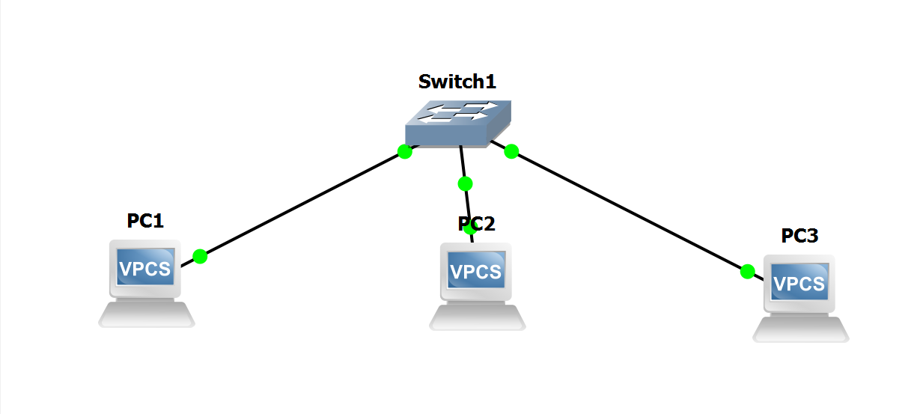

**Pinging PC1 to PC 2**

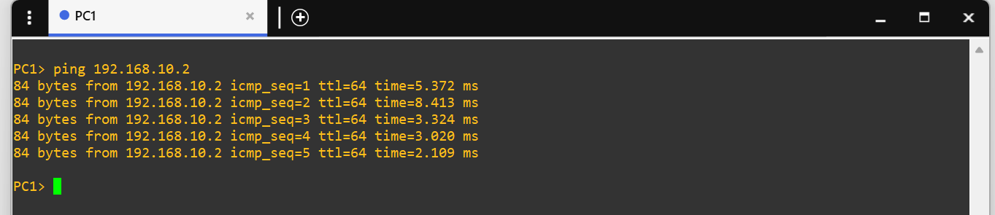

**Pinging PC2 to PC3**

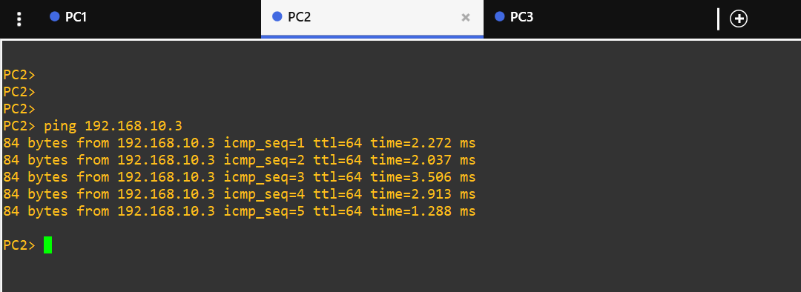

**Pinging PC3 to PC1**

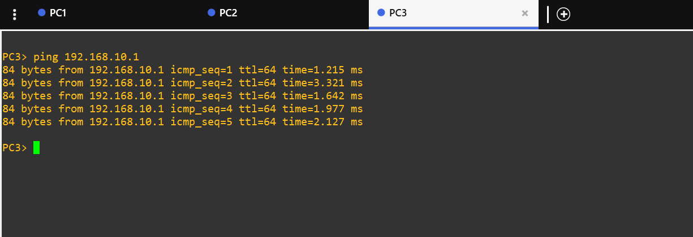

**Capturing packets using Wireshark ( PC1&PC2)**

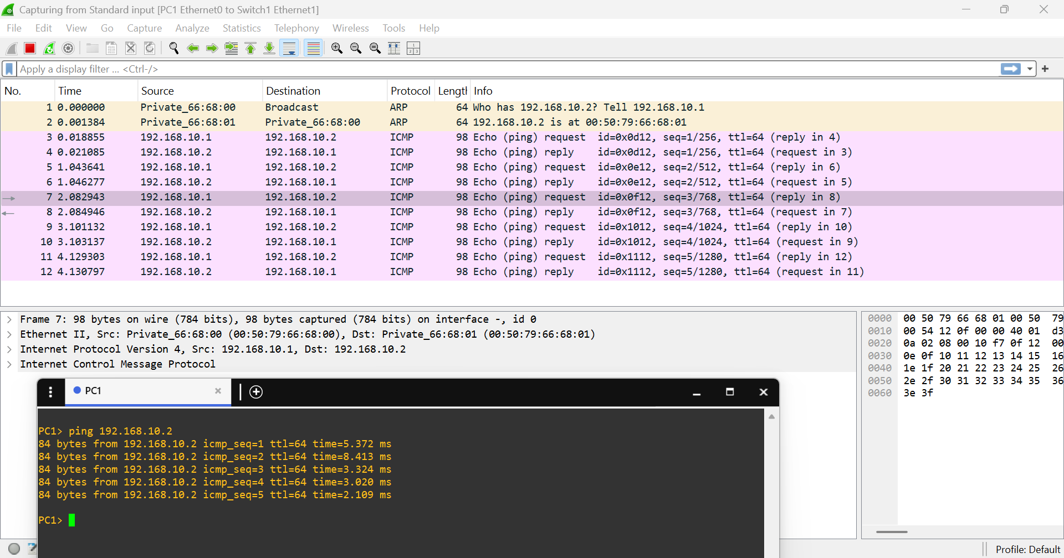

**Frame Observations:**

